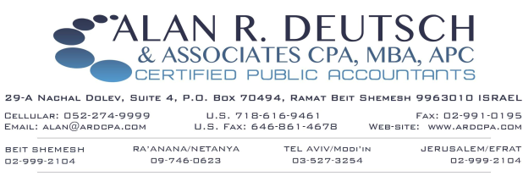

Send information to INFO@ardcpa.com or fax to 077-318-2343
INCOME INFORMATION NEEDED to prepare your U.S. Income Tax Return
Where applicable, please provide the following:
- SALARY: Israeli Form (Tofes) 106 and/or U.S. Form W-2 (or other applicable wage statement)
- PENSION – Israeli Form 106 or US Form 1099-R, as required for distribution received
- SELF EMPLOYMENT INCOME: Profit/Loss schedule if filing an Israeli tax return (doch revach v’hefsed) and/or U.S. Form 1099 (or other schedule indicating self employment income)
- MATERNITY PAY/UNEMPLOYMENT: Year end Israeli statement from Bituach Leumi
- KEREN HISTALMUT: Distributions from your education or other similar fund
- SOCIAL SECURITY: U.S. Form 1099 – SSA
- U.S. INTEREST/DIVIDENDS/SALES OF SECURITIES: U.S. Form 1099 issued by payor and/or brokerage firm or other investment advisor
- ISRAELI or other NON-U.S. INTEREST/DIVIDENDS/CAPITAL GAINS: Form 867 from Israeli Bank or financial institution or other investment advisor or other document indicating non-U.S. or non-Israeli investment income. Mutual funds investment (Kranot Neemanot), If this describes your investment, please contact us for a list of proper documentation to provide. You may be subject to strict US PFIC Rules.
- CORPORATE (‘S’ Corp and ‘C’ Corp) and/or PARTNERSHIP (including LLC (Limited Liability Corporation) INCOME: Including U.S. Form K-1, income, expense amounts and credits
- Israeli (or other non-U.S.) Financial Statement (Ma’azan) if you have Israeli or other foreign corporation
- RENTAL PROPERTY: Including rental income, expense amounts (mortgage interest, repairs, arnona) original cost of the property, date of purchase plus improvements located the U.S., Israel or any other country
- RENTAL RESIDENCE SOLD: Sales contract / closing statements, purchase contract, cost of improvements, Mas Shevach paid, legal fees
- UNIVERSITY TUITION PAID: Form 1098-T (for Israeli universities – paid tuition statement
- GIFT FROM NON-US PERSON/DISTRIBUTION FROM FOREIGN TRUST: Gift / Distribution details
- ANY OTHER WORLD-WIDE INCOME, EXPENSES OR CREDITS NOT MENTIONED ABOVE
- FBAR: Highest balance or yearend statements of non-US checking and savings accounts, as well as pensions, Keren Hishtalmut, brokerage accounts, mutual funds and unit trusts.

NEW CLIENTS SHOULD PROVIDE:

- COPY OF PREVIOUS YEAR'S U.S. and/or ISRAELI TAX RETURNS
- COPY OF SOCIAL SECURITY CARD(S)
- DATES OF BIRTH

